Group-3
OBJECT ORIENTED PROGRAMMING LAB
ASSIGNMENT-2
- Write a C++ program to create a class Student with data members name and rollNo. Use a default constructor to initialize these values and display the student details?
Ans1.
#include <iostream>
using namespace std;
class Student
{
string name;
int rollno;
public:
Student()
{
name="mohit";
rollno=101;
}
void display()
{
cout<<"student Name: " <<name <<endl;
cout<<"rollno: "<<rollno <<endl;
}
};
int main()
{
Student s;
s.display();
}

Ans 1 output :- 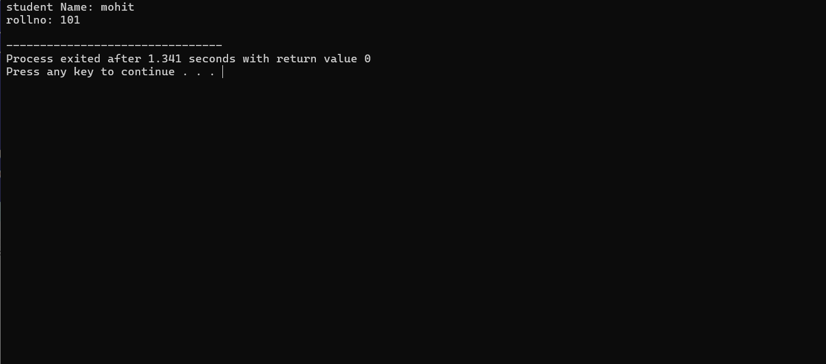
- Create a class Rectangle having data members length and breadth. Use a parameterized constructor to initialize the values and display the area of the rectangle
Ans2.
#include <iostream>
using namespace std;
class Rec
{
int length,breadth,area;
public:
Rec(int l, int b)
{
length=l;
breadth=b;
}
void display()
{
cout<<"area of rectangle="<<length*breadth;
}
};
int main()
{
Rec r(10,5);
r.display();
}
A ns 2. output:- 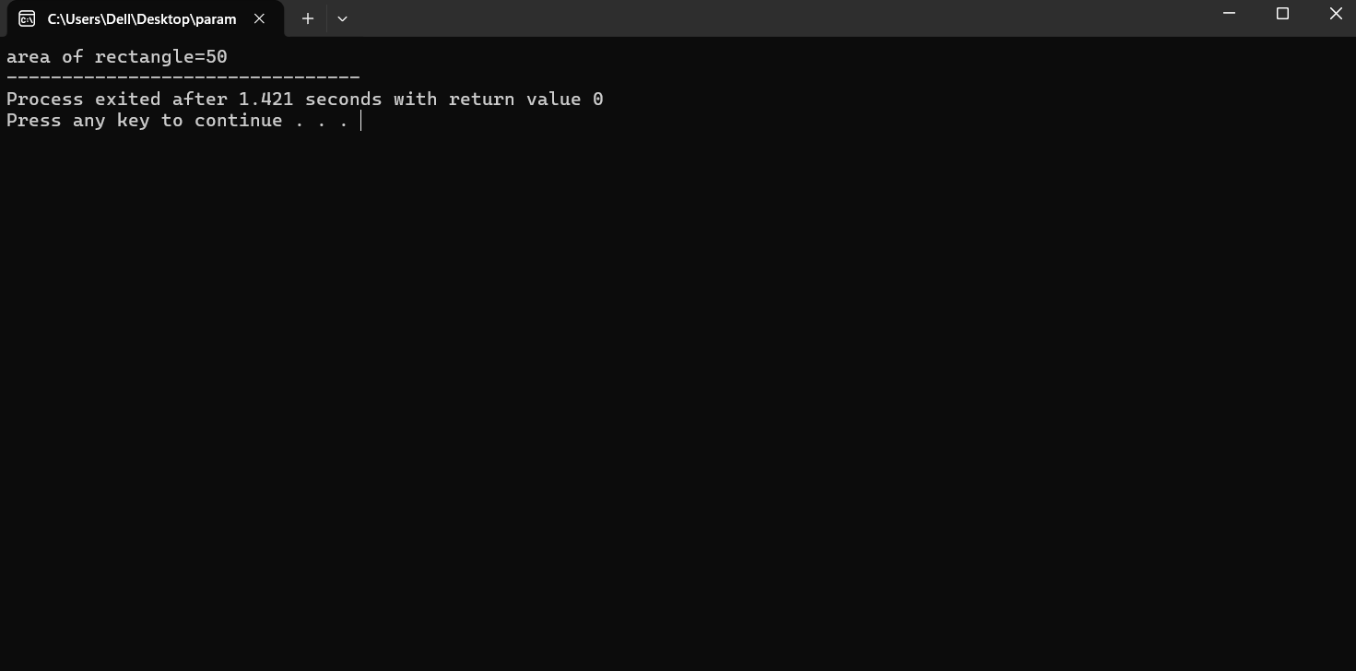

- Write a C++ program to create a class Employee with data members name, id, and salary. Initialize the data members using a parameterized constructor and display the employee details.
Ans 3.
#include <iostream>
using namespace std;
class Employee
{
string name;
int id;
float salary;
public:
Employee(string n, int i,float s)
{
name=n;
salary=s;
id=i;
}
void display()
{
cout<<"Employee name: "<<name<<endl;
cout<<"Employee Id: "<<id<<endl;
cout<<"Employee salary: "<<salary<<endl;
}
};
int main()
{
Employee e1("Mohit",101,50000);
e1.display();
}
Ans 3. output:-
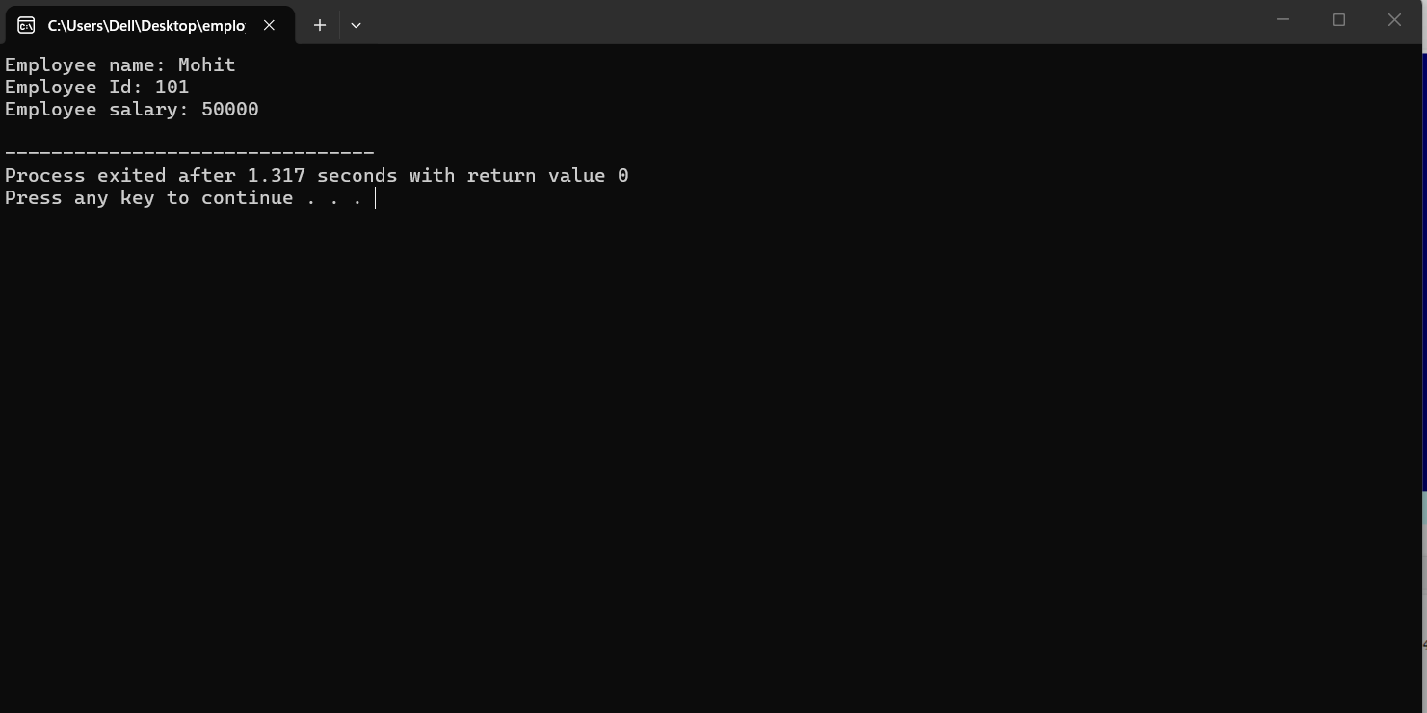4. Create a class Box with data members length, width, and height. Implement:
A. A default constructor,
B. A parameterized constructor,
C. A function to calculate and display volume.
Ans 4. A.
#include <iostream>
using namespace std;
class Box
{
int length,width,height,area;
public:
Box()
{
length=10;
width=5;
height=3;
}
void display()
{
cout<<"length="<<length<<endl;
cout<<"width="<<width<<endl;
cout<<"height="<<height<<endl;
}
};
int main()
{
Box b;
b.display();
}
Ans 4. a. output:-
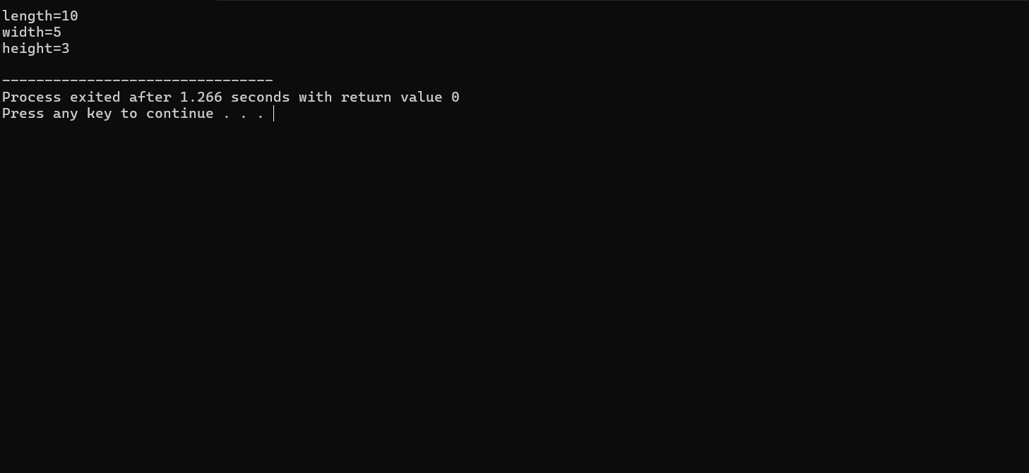
Ans 4.b
#include <iostream>
using namespace std;
class Box2
{
int length,width,height,area;
public:
Box2(int l,int w, int h)
{
length=l;
width=w;
height=h;
}
void display()
{
cout<<"length="<<length<<endl;
cout<<"width="<<width<<endl;
cout<<"height="<<height<<endl;
}
};
int main()
{
Box2 b(10,20,30);
b.display();
}
Ans 4. b. output:-
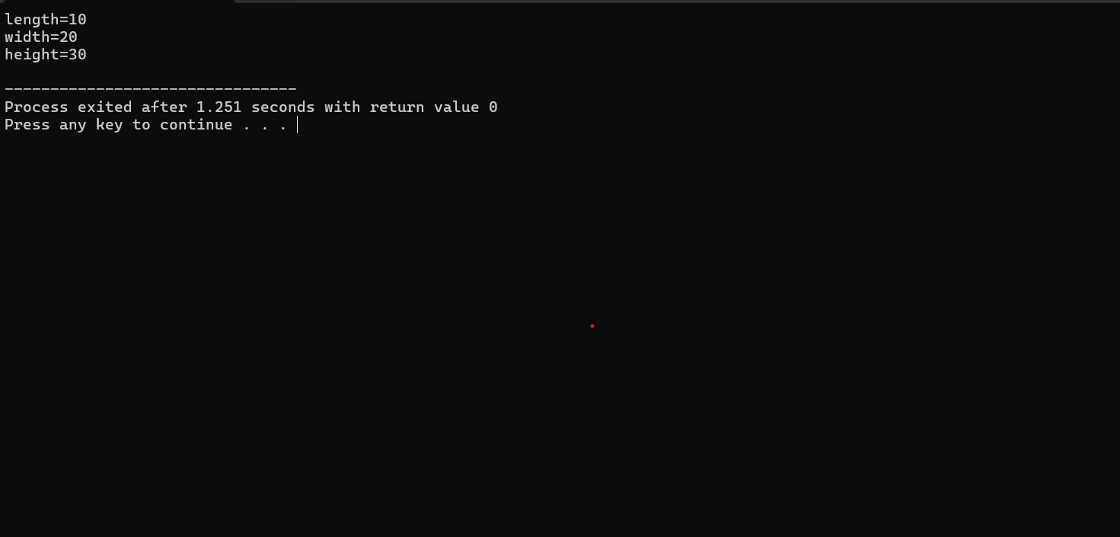
Ans 4.c
#include <iostream>
using namespace std;
class Box3
{
float length,width,height,volume;
public:
void input()
{
cout<<"enter the length";
cin>> length;
cout<<"enter the width";
cin>>width;
cout<<"enter the height";
cin>> height;
}
void calculate()
{
volume=length*width*height;
}
void display()
{
cout<<"volume of box="<<volume;
}
};
int main()
{
Box3 b;
b.input();
b.calculate();
b.display();
}
Ans 4. c. output:-
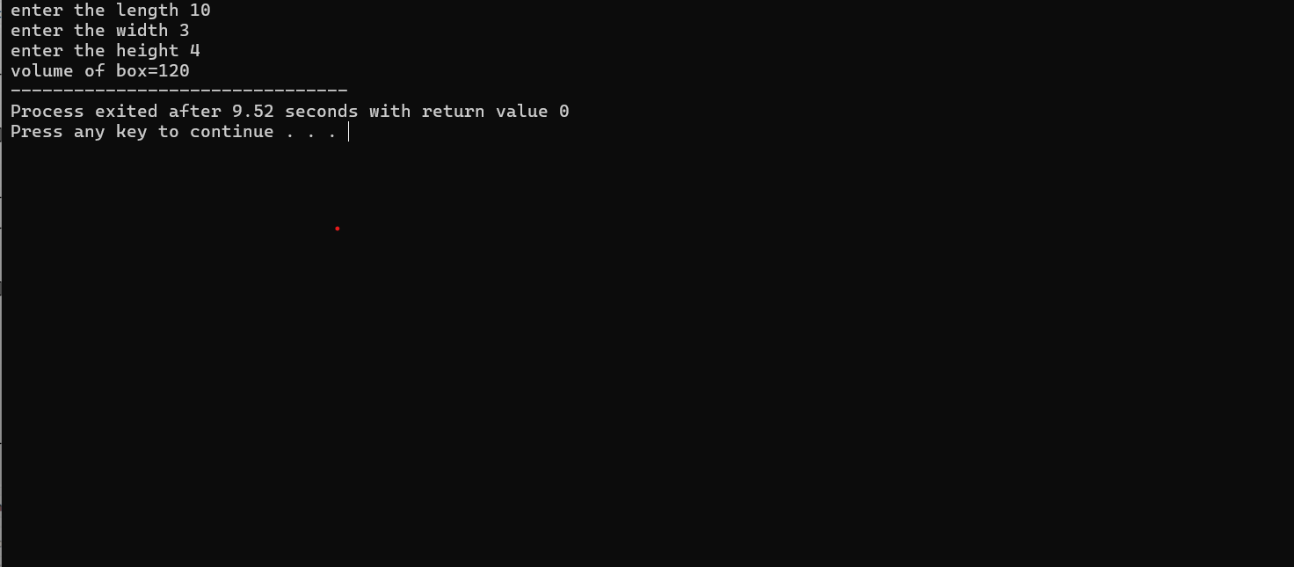

5. Write a program to demonstrate constructor overloading using a class Student. Create:
A. default constructor
B. constructor accepting name and roll number,
C. a constructor accepting name, roll number, and CGPA. Display the details of objects created using all three constructors.

Ans 5. A.
#include <iostream>
using namespace std;
class Student
{
string name;
int rollno;
float cgpa;
public:
Student()
{
name="Mohit garg";
rollno=101;
cgpa=10;
}
Student(string n,int r)
{
name=n;
rollno=r;
cgpa=10;
}
Student(string n, int r, float c)
{
name=n;
rollno=r;
cgpa=c;
}
void display()
{
cout<<"Name"<< name<<endl;
cout<<"Roll no"<<rollno<<endl;
cout<<"cgpa:"<<cgpa<<endl;
}
};
int main()
{
Student s1;
Student
s2("Mohit",101);
Student s3("Rahul",102,8.5);
cout <<"Student 1:"<<endl;
s1.display();
cout <<"Student 2:"<<endl;
s2.display();
cout <<"Student 3:"<<endl;
s3.display();
}
Ans 5. output:-
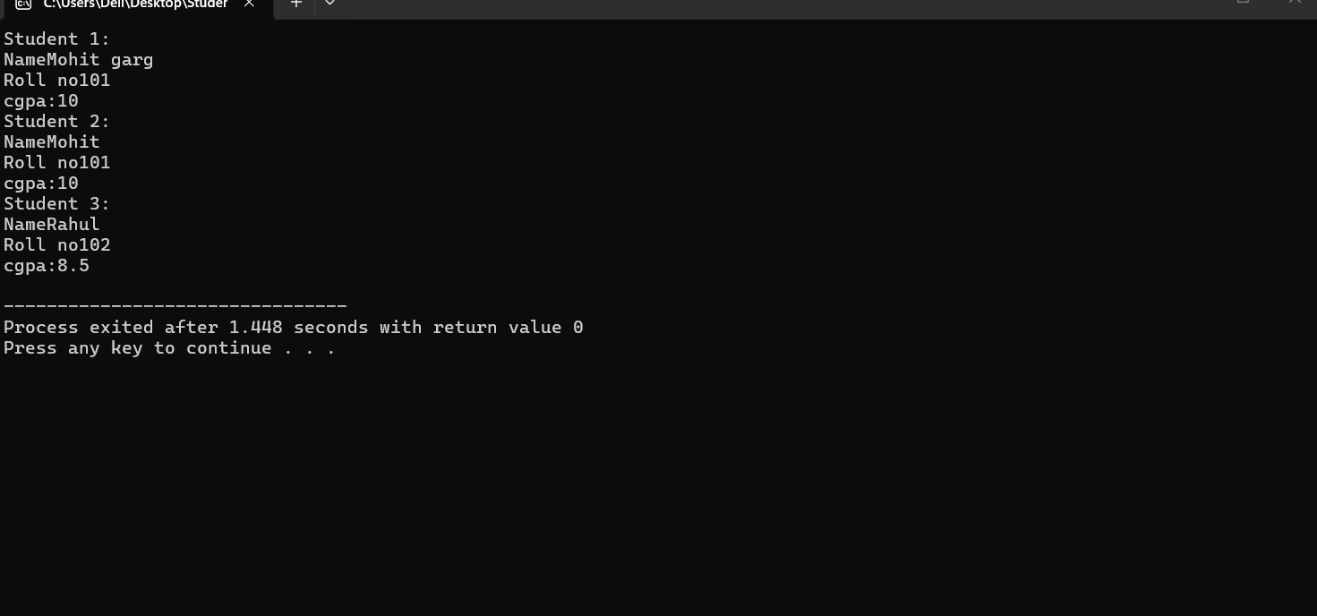

6. Create a class Complex with real and imaginary data members. Implement:
A. a default constructor
B. a parameterized constructor
C. a display function.
Ans6:
#include <iostream>
using namespace std;

class Complex
{
float real, imaginary;

public:
Complex()
{
real = 0;
imaginary = 0;
}
Complex(float r, float i)
{
real = r;
imaginary = i;
}
void display()
{
cout << real << " + " << imaginary << "i" << endl;
}
};

int main()
{
Complex c1;

Complex c2(5, 3);

cout << "Complex number using default constructor: ";
c1.display();

cout << "Complex number using parameterized constructor: ";
c2.display();

return 0;
}
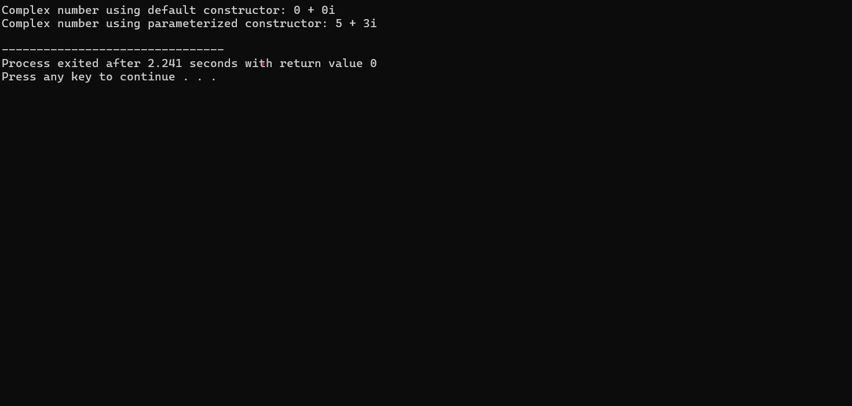

7. Create a class Demo that displays a message when its constructor is called and another message when its destructor is called. Create multiple objects of the class and observe the order in which constructors and destructors execute?
Ans 7.
#include <iostream>
using namespace std;
class Demo
{
public:
Demo()
{
cout << "Constructor called" << endl;
}
~Demo()
{
cout << "Destructor called" << endl;
}
};

int main()
{
Demo obj1;
Demo obj2;
Demo obj3;
cout << "All objects are created." << endl;
return 0;
}
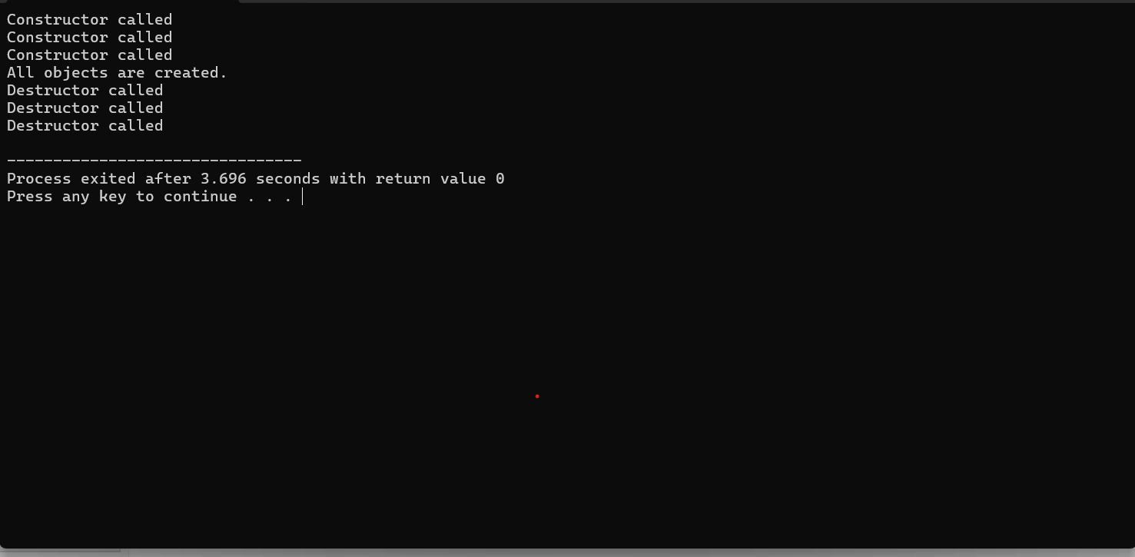
8. Write a C++ program to demonstrate the execution order of constructors and destructors when objects are created inside main() and inside a separate function?
Ans 8.
#include <iostream>
using namespace std;

class Demo
{
public:
Demo()
{
cout << "Constructor called" << endl;
}

~Demo()
{
cout << "Destructor called" << endl;
}
};
void show()
{
Demo obj2;
Demo obj3;
cout << "Objects created inside function" << endl;
}
int main()
{
Demo obj1;
cout << "Object created inside main()" << endl;
show();
cout << "Back to main()" << endl;
return 0;
}